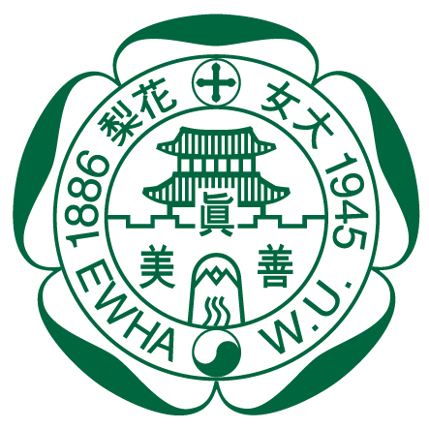
Ewha Womans University

Please affix a recent photo

College of Medicine

APPLICATION FOR CLINICAL CLERKSHIP

If you are interested in exchange students' clinical clerkship at the Ewha Womans University College of Medicine, this form must be sent to Ms. Yunjung Jung (jyj@ewha.ac.kr).
It would be best if we could have you apply at least 6 months in advance.

- Personal Information
Family name
Given name
Date of birth (YYYY/MM/DD) |  | Sex | □ male □ female
Passport number |  | Date of expiry
Nationality
Current address
E-mail address |  | Phone
Languages Spoken | □ Korean, □ English, □ Japanese, □ Chinese □ German,  □ French, Others
Name and Place of
Home Institution/Medical School
Emergency contact person and phone number

Current year of studies (Please mark): year 3 / 4 / 5 / 6
Length of Medical Studies at your School (Please mark): 4 / 5 / 6 years
Expected date of graduation:

- Application
Note: You will not be able to treat patients or assist in patient treatment.
Please refer to the following website for available clerkship courses at Ewha. http://eng.eumc.ac.kr
Practice may not be possible depending on the circumstances of the department. Therefore, we recommend that you give priority to 3-5 desired courses.

Desired Clinical Department: | Contact person at the Ewha Womans University College of Medicine in case you already have a potential supervisor:
1
2
3
4
5

- Time schedule of clerkship:
Duration in week(s)
Date | from:  (day / month / year) | to:  (day / month / year)

- Accommodation
Do you need accommodation (dormitory at Ewha Womans University)?
□ Yes / □ No
If yes, please provide your flight information including the date:

Arrival:

Departure:

If No, please provide your accommodation information in Seoul.

Address:

Phone:

- Declaration
I hereby declare that the information provided above is true to the best of my knowledge and will abide by whatever decision the Ewha Womans University College of Medicine makes with regard to my application.

Date: Signature:

- Required documents
Please submit the following materials attached to this application.
- Copy of Passport identification page
- CV (in Korean or English)
- Immunization Record (in Korean or English)
- Letter of Reference (in Korean or English)
- Photo for ID card
- Certificate of Travel Insurance (in Korean or English)

You can submit No. 6 after you arrive.
Note: Your application will be accepted only if all required documents are attached

